

**Polling District and Polling Place Review 2025**

**Kenton Ward**

**Parliamentary Constituency:** Cramlington and Killingworth | Hexham | North

**(Proposed) Polling Districts:** N01, N02, N03, N04, N05, N06

The Local Government Boundary Commission for England are an independent body accountable to Parliament. They are responsible for reviewing councils to make sure their patterns of internal wards are fair and sensible. Their reviews include at least two rounds of public consultation before they make recommendations for change.

The final recommendations were published on 7 January 2025, and the new arrangements apply to local elections from 2026.

As a result of changes to ward boundaries the Acting Returning Officer (ARO) is conducting a review of polling districts and polling places to ensure that they are suitable for the new ward boundaries.

For more information on the local government boundary review visit: <https://www.lgbce.org.uk/all-reviews/newcastle-upon-tyne>

This document provides details of the review, along with the initial recommendations and comments of the Acting Returning Officer (ARO). Also, the election rules require the ARO to decide how many polling stations are required for each polling station and the ARO must allocate electors to the polling stations in such manner as they think most convenient.

These recommendations will be open to all residents, stakeholders, and any interested parties. We shall be seeking representations from local disability groups on the accessibility and suitability of polling places. Any comments should be addressed in the first instance to pollingplaces@newcastle.gov.uk where they will be collated on behalf of the (Acting) Returning Officer.

We considered the following factors:

* **Identifying new polling places:** We will look for new polling places in areas where the existing provision is unsuitable or unavailable.
* **Feedback:** We will consider feedback received following recent elections, consultation from members of the public, elected members, and other stakeholders.
* **Accessibility:** We will try to ensure that every polling place is accessible to electors with disabilities.
* **Facilities**: We will make sure that all electors have such reasonable facilities for voting as are practicable in the circumstances.
* **Elector numbers:** We will try to comply with the Electoral Commission guidance on the maximum number of electors that should be allocated to a polling station which should not exceed 2,250.
* **Future housing developments**: We will consider the impact of proposed housing developments on polling station electorates.

**(Current) Kenton Ward**

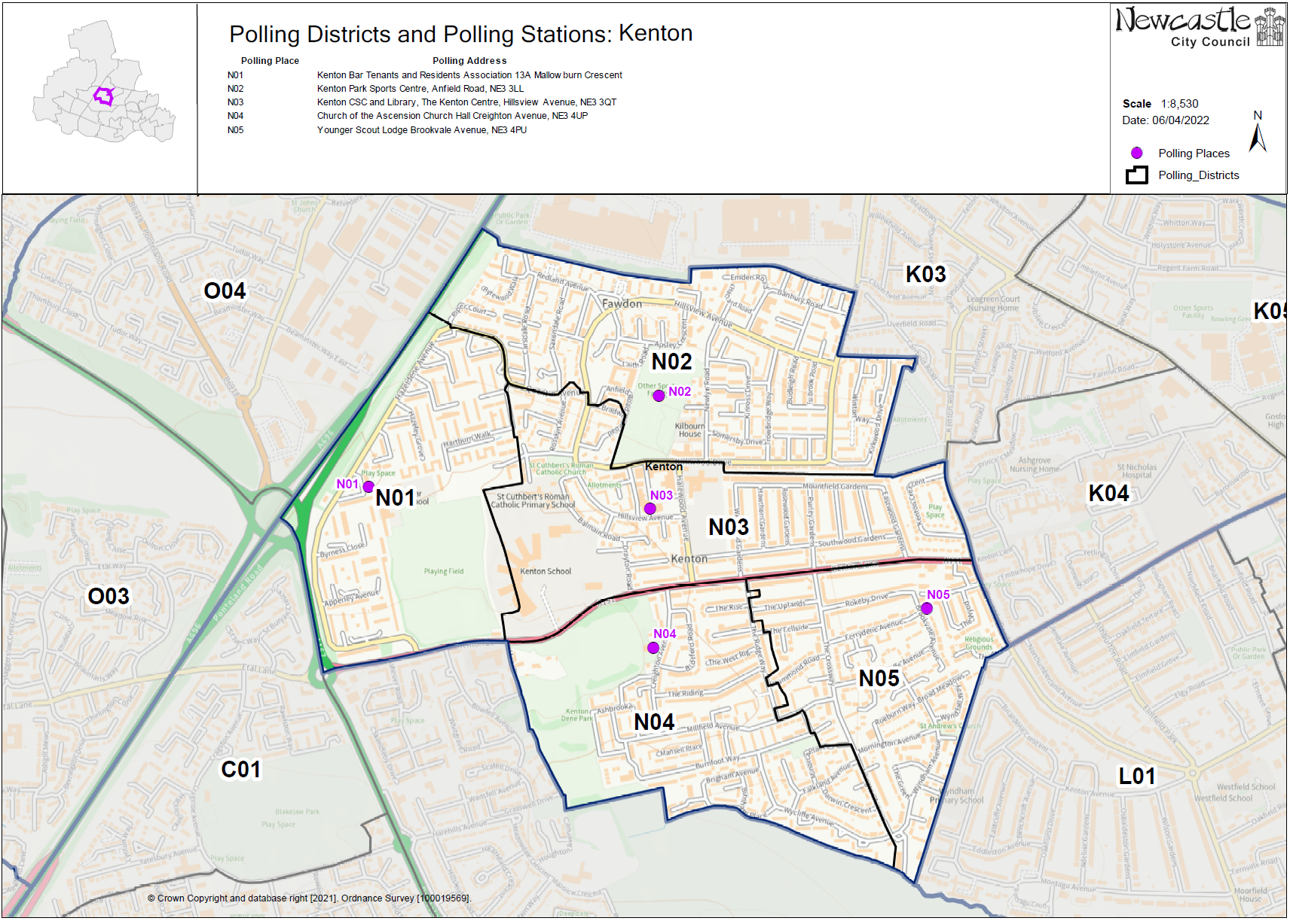This map shows the current ward and polling district boundaries and the polling places.

**(New)**

**Kenton Ward**

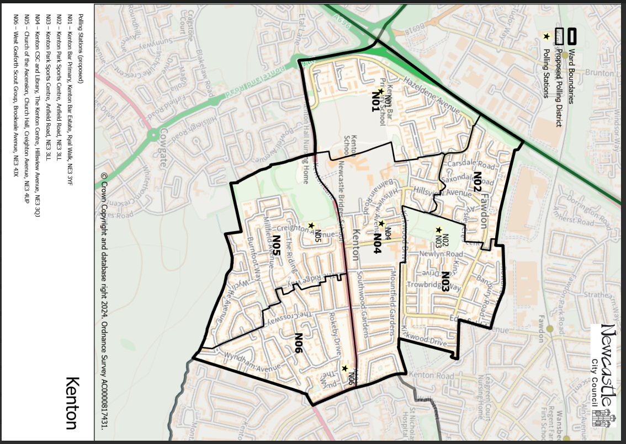

This map shows the new ward and the proposed polling districts and the proposed polling places.

* **N01** – Kenton Bar Primary, Kenton Bar Estate, Ryal Walk, NE3 3YF
* **N02** – Kenton Park Sports Centre, Anfield Road, NE3 3LL
* **N03** – Kenton Park Sports Centre, Anfield Road, NE3 3LL
* **N04** – Kenton CSC and Library, The Kenton Centre, Hillsview Avenue, NE3 3QJ
* **N05** – Church of the Ascension, Church Hall, Creighton Avenue, NE3 4UP
* **N06** – West Gosforth Scout Group, Brookvale Avenue, NE3 4JX

**Kenton Ward**

**Polling District N01**

|  |
| --- |
| **Considerations and Proposals** |
| No change to the polling district boundary.  Kenton Bar TARA has closed, and the building is no longer available. Kenton Bar Primary School is located centrally within the proposed N01 district, site visit still required. If we can’t use Kenton Bar Primary School, then the proposal would be to use Kenton Customer Service Centre as a double station. |

|  |  |
| --- | --- |
| **Current Polling District** | **Current Polling Place** |
| N01 (full) | Kenton Bar Tenants and Residents Association (TARA), 13A Mallowburn Crescent, NE3 3YL |

|  |  |  |
| --- | --- | --- |
| **Proposed Polling District** | **Predicted**  **Polling Station Electorate** | **Proposed Polling Place** |
| N01 | 714 | Kenton Bar Primary, Kenton Bar Estate, Ryal Walk, NE3 3YF |

|  |
| --- |
| **Preliminary Consultation – Elected Members comments and feedback** |
| No comments received. |

**Kenton Ward**

**Polling District N02**

|  |  |
| --- | --- |
| **Current Polling District** | **Current Polling Place** |
| N02 (part of) | Kenton Park Sports Centre, Anfield Road, NE3 3LL |

|  |  |  |
| --- | --- | --- |
| **Proposed Polling District** | **Predicted**  **Polling Station Electorate** | **Proposed Polling Place** |
| N02 | 571 | Kenton Park Sports Centre, Anfield Road, NE3 3LL |
|  | | |

|  |
| --- |
| **Considerations and Proposals** |
| Part of current N02 district would become the proposed N02 district. Most of the properties to the west of Apsley Crescent would form the proposed N02 district.  No change to the polling place.  Kenton Park Sports Centre is suggested as a double polling station for the proposed districts of N02 and N03. |
|  |

|  |
| --- |
| **Preliminary Consultation – Elected Members comments and feedback** |
| No comments received. |

**Kenton Ward**

**Polling District N03**

|  |  |
| --- | --- |
| **Current Polling District** | **Current Polling Place** |
| N02 (part of) | Kenton Park Sports Centre, Anfield Road, NE3 3LL |

|  |  |  |
| --- | --- | --- |
| **Proposed Polling District** | **Predicted**  **Polling Station Electorate** | **Proposed Polling Place** |
| N03 | 854 | Kenton Park Sports Centre, Anfield Road, NE3 3LL |
|  | | |

|  |
| --- |
| **Considerations and Proposals** |
| Part of current N02 district would become the proposed N03 district. Most of the properties to the east of Apsley Crescent would form the proposed N03 district.  No change to the polling place. Kenton Park Sports Centre is suggested as a double polling station for the proposed districts of N02 and N03. |
|  |

|  |
| --- |
| **Preliminary Consultation – Elected Members comments and feedback** |
| No comments received. |

**Kenton Ward**

**Polling District N04**

|  |  |
| --- | --- |
| **Current Polling District** | **Current Polling Place** |
| N03 (full) | Kenton CSC and Library, The Kenton Centre, Hillsview Avenue, NE3 3QJ |

|  |  |  |
| --- | --- | --- |
| **Proposed Polling District** | **Predicted**  **Polling Station Electorate** | **Proposed Polling Place** |
| N04 | 889 | Kenton CSC and Library, The Kenton Centre, Hillsview Avenue, NE3 3QJ |
|  | | |

|  |
| --- |
| **Considerations and Proposals** |
| Current N03 would become the proposed N04. No changes to the polling district boundary.  No changes to the polling place. |
|  |

|  |
| --- |
| **Preliminary Consultation – Elected Members comments and feedback** |
| No comments received. |

**Kenton Ward**

**Polling District N05**

|  |  |
| --- | --- |
| **Current Polling District** | **Current Polling Place** |
| N04 (full) | Church of the Ascension, Church Hall, Creighton Avenue, NE3 4UN |

|  |  |  |
| --- | --- | --- |
| **Proposed Polling District** | **Predicted**  **Polling Station Electorate** | **Proposed Polling Place** |
| N05 | 846 | Church of the Ascension, Church Hall, Creighton Avenue, NE3 4UN |

|  |
| --- |
| **Considerations and Proposals** |
| Current N04 would become the proposed N05. No changes to the polling district boundary.  No changes to the polling place. |

|  |
| --- |
| **Preliminary Consultation – Elected Members comments and feedback** |
| No comments received. |

**Kenton Ward**

**Polling District N06**

|  |  |
| --- | --- |
| **Current Polling District** | **Current Polling Place** |
| N05 (full) | West Gosforth Scout Group, Brookvale Avenue, NE3 4JX |

|  |  |  |
| --- | --- | --- |
| **Proposed Polling District** | **Predicted**  **Polling Station Electorate** | **Proposed Polling Place** |
| N06 | 861 | West Gosforth Scout Group, Brookvale Avenue, NE3 4JX |

|  |
| --- |
| **Considerations and Proposals** |
| Current N05 would become the proposed N06. No changes to the polling district boundary.  No change to the polling place. |

|  |
| --- |
| **Preliminary Consultation – Elected Members comments and feedback** |
| No comments received. |